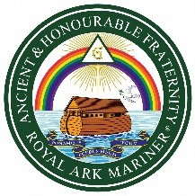

The Ancient and Honorable Fraternity of Royal Ark Mariner

TOAST LIST
After Grace

His Majesty The King
***
Most Worshipful Brother His Royal Highness Prince Michael of Kent, GCVO GRAND MASTER
***
Most Worshipful Brother John Herbert Prizeman PRO GRAND MASTER
Right Worshipful Brother Francis Charles Spencer DEPUTY GRAND MASTER
Right Worshipful Brother Denovan Keith Wilson
ASSISTANT GRAND MASTER
and the Members of the Grand Master’s Royal Ark Council
***
Right Worshipful Brother Barrie Roy Mansell
DISTRICT GRAND MASTER
***
HOLDERS OF ROYAL ARK MARINER GRAND RANK
***
Worshipful Brother Rodney Stuart Hales
DEPUTY DISTRICT GRAND MASTER
Worshipful Brother Michael John Baker
Worshipful Brother Terrence Porter
ASSISTANT DISTRICT GRAND MASTERS
and holders of District Grand Rank
***
The Worshipful Commander
***
The Candidate(s)*
***
The Visitors*
***
The Warder’s Toast

* When applicable

