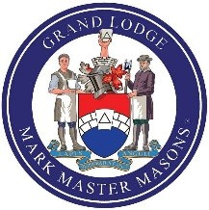

The Grand Lodge of Mark Master Masons of England and Wales and its Districts and Lodges Overseas

TOAST LIST
After Grace

His Majesty The King
***
Most Worshipful Brother His Royal Highness Prince Michael of Kent, GCVO GRAND MASTER
***
Most Worshipful Brother John Herbert Prizeman PRO GRAND MASTER
Right Worshipful Brother Francis Charles Spencer DEPUTY GRAND MASTER
Right Worshipful Brother Professor. Denovan Keith Wilson
ASSISTANT GRAND MASTER
and the rest of the Grand Officers,
present and past
***
Right Worshipful Brother Barrie Mansell
DISTRICT GRAND MASTER
***
Worshipful Brother Rodney Hales
DEPUTY DISTRICT GRAND MASTER
Worshipful Brother Michael Baker
Worshipful Brother Terry Porter
ASSISTANT DISTRICT GRAND MASTERS
and the rest of the Provincial/District Grand Officers,
present and past
***
The Worshipful Master
***
The Candidate(s)*
***
The Visitors*
***

The Tyler's Toast

* When applicable

